summer sizzler AVS

JULY 14 & 15, 2018
(Regions 13 & 14 Qualifier)

Champions Center
Springfield, Ohio
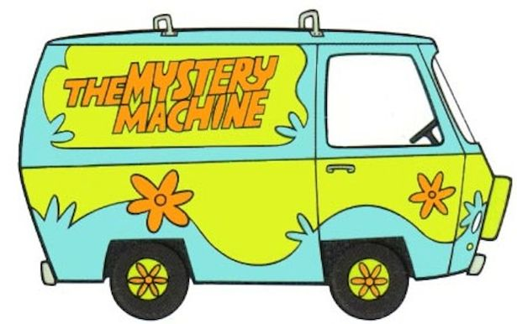

AVS Mystery solved!
Exhibiting at an Arabian Value Show WILL qualify you for regionals and nationals.
You DO accrue points.
USEF membership is NOT required!

What’s special about Summer Sizzler AVS?
Youth High Point with prizes! Ranch Horse! Reining!

Sport Horse! Barrels!

