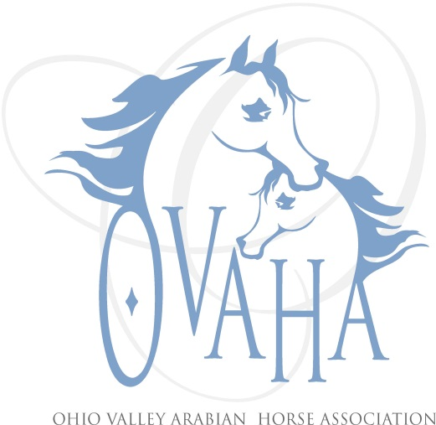
SUMMER SIZZLER AVS

July 14 & 15, 2018

Champions Center
Clark County Fairgrounds
Springfield, Ohio

SPONSORSHIP/ADVERTISEMENT FORM

NAME_____________________________________________________PHONE ____________________
BUSINESS NAME ____________________________________________EMAIL _____________________
ADDRESS_____________________________________________________________________________

ADS AND LOGOS FOR BANNERS MUST BE EMAILED ON OR BEFORE JULY 6, 2018 to sherri.lewis@co.warren.oh.us .
SPONSORSHIP & ADVERTISEMENT PACKAGES
(Class sponsorships available before or during Sizzler!)

- $25 (Two Classes)

- $ _____ Other amount for a specific event (ie: Exhibitor’s Party, Kids prize packages, ribbons, etc.). Please indicate or comment(s) ___________________________________________________________________________.

- $100 Sponsor announcements; 1/3 page/Business card ad in prize list.

- $200 Banner to be placed in warm-up arena; Sponsor announcements; ½ page ad in prize list.

- $300 Banner to be placed in warmup arena; Sponsor announcement; full page ad in prize list. Premium front stalling.

