SUMMER SIZZLER AVS

(AHA Value Show)
Regions 13 & 14 Qualifier

July 14 & 15, 2018

Champions Center
4122 Laybourne Road
Springfield, Ohio 45505

SUMMER SIZZLER AVS

CONCURRENT HORSE SHOW – Regions 13 & 14
SATURDAY, JULY 14, 2018 and SUNDAY, JULY 15, 2018

SHOW OFFICIALS

Judge A – Region 13 CHELSEA WESSON
Litchfield, IL

Judge B – Region 14 STEVEN DUELL
Traverse, MI

Sport Horse Judge PATRICIA HARPER
Region 14 Delaware, OH

Show Manager SHERRI LEWIS 513.335.3611

Show Secretary EVETTE MOODY 937.623.7934
blueribbonhs@sbcglobal.net

Barn Manager TAMMY HAWKEY 937.239.8028
tiaraarabs@aol.com

Shavings $8/Bag, two bag minimum order

Photographer Jeff & Stacy Wright 330.844.4482
foreverworks.photoreflect.com

Announcer Larry Kineer

ARRIVAL INFORMATION: The barn and show office will be open at noon on Friday, July 13, 2018. Remaining times to be posted. Stabling will be available no earlier than noon on Friday, July 13, 2018. Departure no later than 9:00 AM on Monday, July 16, 2018. Anyone requiring early arrival or later departure MUST MAKE ARRANGEMENTS WITH THE BARN MANAGER, TAMMY HAWKEY 937.239.8028 or tiaraarabs@aol.com by July 1st. Bedding is not provided, but is available on the grounds at $8 per bag, 2 bag minimum. IT IS STRONGLY SUGGESTED THAT BEDDING BE ORDERED IN ADVANCE SO THAT IT HAS ALREADY BEEN DELIVERED TO YOUR STALLS PRIOR TO YOUR ARRIVAL.
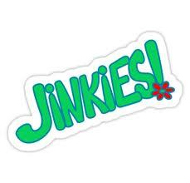

ANY PERSON OWING MONEY TO ANY SHOW HELD IN REGIONS 13 OR 14 WILL NOT BE PERMITTED TO SHOW AT THIS SHOW UNLESS ALL AFOREMENTIONED OBLIGATIONS ARE SATISFIED PRIOR TO ENTERING.

ENTRY FEES:
Halter Classes 6 Ribbons $25.00
Halter Championships Champion/Reserve
Champion N/C
Performance Classes 6 Ribbons $25.00
Performance Championships 6 Ribbons $25.00
Exhibition Classes 6 Ribbons $10.00
Pre-entries close July 2, 2018

OTHER FEES:
Horse/Tack Stalls Per Weekend $75.00
BEDDING NOT INCLUDED-No outside bedding allowed.
Early Arrival Per Stall Per Day $15.00
Grounds Fee Per Horse $15.00
Camping Per Day $35.00
All campers that are found not to have purchased a parking pass will be subject to a $100 fine and/or towed at the owner’s expense.
Office Fee Per Horse $25.00
Post Entry Fee Per Horse $25.00
AHA Fee Per Horse $ 8.00
AHA Res 9-90 Fee Per Horse $ 7.00
AHA Single Event (SEM) $35.00
USEF Drug Fee, Show Pass Fee and
Competition Membership ($96 savings) NOT REQUIRED!
AHA Value Shows only count toward AHA qualifications and programs.

Post entry fees will be charged on all incomplete entries, entries received without payment and those entries postmarked after July 2, 2018. POST ENTRIES MUST BE MADE AT LEAST ONE SESSION PRIOR TO THE START OF THE SESSION TO BE ENTERED.

Classes will be run and adjudicated based on the current USEF Rulebook. All decisions made by the Judge and/or Show Management are final and cannot be protested. Show Management reserves the right to ask any exhibitor to leave the show grounds for any reason including but not limited to: unsportsmanlike conduct and animal cruelty.
Copies of Registration papers and current AHA competition membership cards for owners, trainers and rider must be presented at time of entries.

TBA Classes – Exhibitors may add a class to the show from the listed TBA classes with the payment of $40 with their entries. TBA classes will be added on a first come, first serve basis from the list of potential TBA classes. The TBA fee does not include entry fees. You may purchase any class that is on the 2018 AHA list or recognized by AHA, except for the following classes and divisions, the will NOT be offered: Cutting Horse, Working Cow Horse, Rained Cow Horse, Team Penning, Working Hunter, Jumper Classes, Carriage Pleasure Driving, Eventing Trials, Exhibition classes from Sec 133, Working Hunter Warm Up, Competitive Trail Rides or Endurance Rides, Trail, Dressage. Sport Horse TBA classes may only be scheduled on Saturday.

Rings – The main ring is an Outdoor Covered Arena 274’ x 130’, sand based with white vinyl fencing. The make up covered arena is 72’ x 130’ sand based and there is an additional outdoor arena 11’ x 85’.

Entries will be accepted no later than the end of the prior session. There will be only one owner per entry blank. Every exhibitor or his/her agent or trainer must sign the entry blank. All fees must accompany entry. Improperly completed entry forms will be returned to the Exhibitor. No entries will be accepted unless payment in full for fees is included. Upon entering additional classes, all fees must be paid at that time, unless an open check is on hand with the show office. NO EXCEPTIONS.

Credit Card payments will be accepted. A 4% processing fee will be assessed to all credit card payments.
THERE WILL BE A $50 SERVICE CHARGE FOR ALL RETURNED CHECKS.

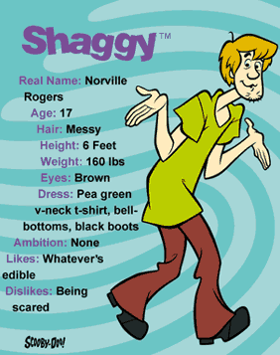

RULES AND REGULATIONS Ruh-roh!
SINGLE JUDGE SYSTEM: Pursuant to Resolution 7-17 all classes will be judged by one judge, and those placings shall prevail. In-Hand Classes shall utilize the “In-Ring” Judging procedures.

Photostat copies of your AHA Membership Card and registration papers (both sides) for each horse entered MUST accompany your entries. Copy of Negative Coggins (6 months) and Health Certificate (30 days) are required for all out-of-state horses.

EVERY CLASS OFFERED HEREIN WHICH IS COVERED BY THE RULES AND SPECIFICATIONS OF THE CURRENT USEF RULE BOOK WILL BE CONDUCTED AND JUDGED IN ACCORDANCE THEREWITH.

Show management will be charged with the responsibility of enforcing all USEF and AHA Rules. Special emphasis will be placed on the rules pertaining to the retention of natural action; expressly hoof length, weighted shoes or action appliances. The use of chains, rollers, or similar devices on the show grounds during or before a show are prohibited and the Show Committee shall bar violators from further participation for the remainder of the show, and they shall forfeit all entry fees and winnings for the entire show. USEF Rule XVI, Chapter I, Article 1601 regarding use of pads and bar shoes will be strictly enforced.

Show Management retains the right to request measurement of hoofs and inspection of pads of any or all horses in any or all classes.

OVAHA, OVAHA BoD, OVAHA Show Management and/or Champions Center/Clark County Fairgrounds accepts no responsibility for loss or damage to any property or equipment, or for any damages to any animal, spectators or exhibitors at this competition.

Dress: It is the tradition of the show ring that riders and drivers be correctly attired for the class in question, THAT ATTENDANTS BE NEATLY DRESSED, and horse properly presented. The Show Committee will bar any entry or person from entering the ring if not suitably presented to appear before an audience.

Cancellation of Classes: The Show Committee reserves the right to cancel or combine any classes or make any scheduling for the betterment of the show.

Disqualifications: If any Exhibitor has made any false statements regarding an animal exhibited, or if any Exhibitor shall attempt to interfere with the Judges in the performance of their duties, he or she shall be excluded from exhibiting. Any action, discourtesy or disobedience to the official on the part of the owner, rider, exhibitor, groom or driver will disqualify the horse from being judged. The Show Management reserves the right to remove any of the previously mentioned (owner, rider, etc.) without being liable to compensation or damages.

Attention Handler: Cruelty to or the abuse of a horse by any person at a recognized show is forbidden. Excessive use of the whip on any horse in stall, runway, schooling area, show ring, or elsewhere on the show grounds before or during a show, by any person, constitutes a violation and renders the offender subject to penalty.

Stallions: Stallions may be shown by women and children in all classes except Lead Line and Walk-Trot.

Junior Exhibitors: Junior Exhibitor classes are limited to riders who have not yet reached their 19th birthday as of December 1st, of the current competition year.

Amateur Classes: Every person who has reached his 18th birthday and competes in classes for amateurs under USEF rules must possess current amateur certification issued by USEF. This certification must be available for inspection or the competitor must have lodged with the Show Secretary at least one hour prior to such class an application for such certification provided by USEF. IN the event that a person holds an unrevoked certification, but does not have it in his immediate possession, the Show Secretary may accept a signed statement to that effect which must be submitted to the USEF.

Calls for Classes: When the stat of any class with no posted order is being delayed by horses not ready to perform, the competition may be closed at the order of the Judge or Show Committee, provided warning is used and exhibitors are given 3 minutes in which to appear at the in-gate ready to participate. In classes in which horses compete collectively, after warning is issued the in-gate must e closed 2 minutes after the first horse enters the ring.

Parking: Specific areas have been set aside for parking of horse trailers and campers. By Order of the State Fire Marshall, there is no parking in front of or between the barns.

Admission to Ring: No persons will be allowed in the ring except participants in class, judge, ringmaster, assistants and show photographer. Attendants will be allowed only after being called by the Judge or Ringmaster.

Stalling: All stalls will be reserved as paid for – NO STALL RESERVATIONS WITHOUT PAYMENT. Stalling is in permanent stalls 8 x 10 made from wood and wire fencing with wood sliding doors. Horses may be shown out of trailers. NO BEDDING IS PROVIDED. Bedding will be available on show grounds. No nails, staples or other devices permitted in the permanent stalls. All stalls will be checked for damages and the exhibitor will be charged for such damage to stall(s).

Sharps Containers will be available in the stall areas. Competition management may fine any individuals including trainers, owners, exhibitors or their agents up to $100 for improper disposal of needles or other sharp disposable instruments.

AHASM Show Number
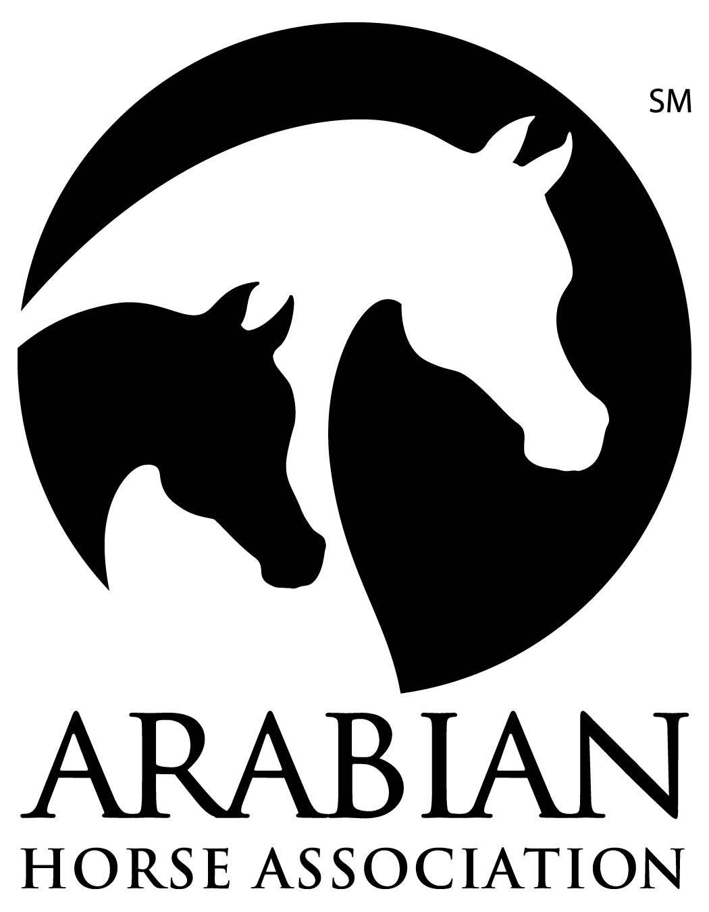
AVS A (Reg 13) 181414288
AVS B (Reg 14) 181314289

THE ARABIAN HORSE ASSOCIATIONSM
RECOGNIZES THE ARABIAN DIVISION OF THIS SHOW

Sponsored By OHIO VALLEY ARABIAN HORSE ASSOCIATION

The Arabian Horse Association is a major equine association serving members in the United States and Canada. It registers and maintains a database of more than one million Arabian, Half-Arabian and Anglo- Arabian horses and administers more than $2.5 million in annual prize money. AHA produces championship events, recognizes over 500 Arabian horse shows and distance rides annually and provides activities and programs that promote breeding and ownership. For information about Arabian, Half-Arabian and Anglo-Arabian horses, call 303-696-4500, e-mail info@ArabianHorses.org or visit ArabianHorses.org

All exhibitors entered in this event must be a current AHA member with a Competition Card or pay a Single Event Membership fee per person. This includes any owner, trainer, driver, rider, or halter handler who exhibits horses in the show ring or signs the entry form as the responsible person for any individual's horse.

To join the OHIO VALLEY ARABIAN HORSE ASSOCIATION please contact SHARON HANKS , 1090 Blue Jay Drive, Enon, Ohio 45323.
Contributions or gifts to AHA are not tax deductible as charitable contributions. However, they may be deductible as ordinary and necessary business expenses if so advised by appropriate tax counsel.
Join AHA through your local club for the following great member benefits:
- Discounted subscription to Modern Arabian Horse magazine
- Reduced rate for competition privileges across a variety of disciplines for local, regional and national AHA-approved shows and rides
- Peace of mind with 1 million in personal liability insurance through Equisure
- Preferred rates on horse registrations and transfers
- Preferred rates on ArabDataSource, the world’s largest online Arabian horse resource
- Numerous opportunities to participate in award recognition and prize money programs
- Show circuits for AHA members at local, regional and national levels

The Judges & Stewards Commissioner is responsible for handling written and signed complaints relating to judges' and stewards' conduct when filed by exhibitors, show officials, AHA members or others, and when accompanied by a ten-dollar ($10.00) filing fee [Resolution 5-90]. Other comments, compliments, questions, inquiries are encouraged when appropriate (no filing fee required). Write: Judges & Stewards Commissioner, 10805 East Bethany Dr, Aurora, CO 80014; (303) 696-4539.

AHA 090031 (Rev. 04/2016)

AHA MEMBERSHIP STATEMENT EACH COMPETITOR (THIS INCLUDES AT LEAST ONE RECORDED OWNER AND ALL TRAINERS, DRIVERS, RIDERS, HALTER HANDLERS, COACHES AND THE PERSON(S) SIGNING THE ENTRY BLANK) IN AN ARABIAN HORSE ASSOCIATION RECOGNIZED ARABIAN DIVISION, AT THE TIME OF ENTRY INTO A COMPETITION, MUST SUBMIT A COPY OF A VALID AHA MEMBERSHIP/COMPETITION CARD, JOIN AHA OR PAY AN AHA SINGLE EVENT MEMBERSHIP FEE PER COMPETITOR. WHEN AN AGENT SIGNS FOR THE OWNER AT AN AHA RECOGNIZED COMPETITION, BOTH THE OWNER AND AGENT MUST BE MEMBERS OF AHA OR PAY THE AHA SINGLE EVENT MEMBERSHIP. SINGLE EVENT MEMBERSHIP IS NOT ACCEPTABLE AT AHA REGIONAL OR NATIONAL COMPETITIONS. EXHIBITORS IN WALK-TROT 10 & UNDER CLASSES ARE EXEMPT FROM AHA MEMBERSHIP REQUIREMENTS AT QUALIFYING COMPETITIONS, BUT MUST HAVE AN AHA MEMBERSHIP WITH COMPETITION CARD AT AHA REGIONAL AND NATIONAL COMPETITIONS. EXHIBITORS IN LEAD LINE CLASSES OR PARENTS/GUARDIANS SIGNING FOR MINORS ARE EXEMPT FROM AHA MEMBERSHIP REQUIREMENTS.

Directions to Champion Center: I-70 E Take exit 59 for OH-41 toward S Charleston
0.2 mi Drive to Laybourne Road in Springfield

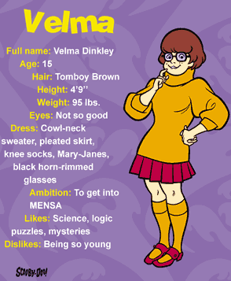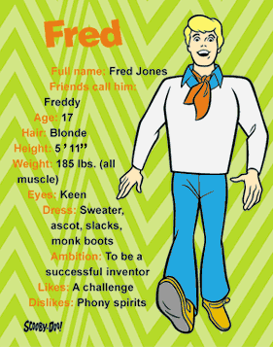
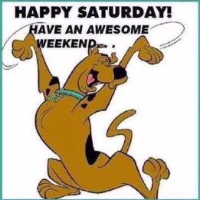
 |  | S A T U R D A Y - 8:00 AM
CLASS # | CODE | NAME
1 | 39 | Arabian Sport Horse Mares In-Hand
2 | 43 | Arabian Sport Horse Mares In-Hand ATH
3 | 53 | Arabian Sport Horse Geldings In-Hand
4 | 57 | Arabian Sport Horse Geldings In-Hand ATH
5 | 46 | Arabian Sport Horse Stallions In-Hand
6 | 475 | HA/AA Sport Horse Mares In-Hand
7 | 479 | HA/AA Sport Horse Mares In-Hand ATH
8 | 494 | HA/AA Sport Horse Geldings In-Hand
9 | 498 | HA/AA Sport Horse Geldings In-Hand ATH
10 |  | A/HA/AA Lead Line All Seats ages 2-6 | Exhibition
11 | 907 | A/HA/AA Equitation Walk/Trot 10 & Under
12 |  | A/HA/AA Equitation Walk/Trot | Exhibition
13 |  | TBA
14 | 130 | Arabian Country Pleasure Driving
15 | 335 | Arabian Sport Horse Under Saddle
16 | 540 | HA/AA Country English Pleasure
17 | 396 | Arabian English Pleasure JTR
18 | 773 | HA/AA Sport Horse Under Saddle
19 | 190 | Arabian Western Pleasure
20 | 351 | Arabian Sport Horse Show Hack ATR
21 | 95 | Arabian Country English Pleasure
22 | 1054 | HA/AA Sport Horse Show Hack ATR
23 | 339 | Arabian Sport Horse Under Saddle ATR
24 | 951 | Western Horsemanship ATR
25 | 777 | HA/AA Sport Horse Under Saddle ATR
26 |  | TBA
 |  | **STICK HORSE**
27 |  | TBA
28 | 620 | HA/AA Western Pleasure
29 | 1066 | Arabian Sport Horse Under Saddle JTR
30 | 733 | HA/AA Hunter Pleasure
31 | 1095 | HA/AA Sport Horse Under Saddle JTR
32 | 2636 | HA/AA Country English Pleasure ATR Select
33 | 336 | Arabian Sport Horse Under Saddle Championship
34 | 774 | HA/AA Sport Horse Under Saddle Championship
35 | 939 | Hunter Seat Equitation Not to Jump ATR
36 | 1836 | Arabian Country English Pleasure ATR Select
37 | 1936 | Arabian Western Pleasure ATR Select
38 |  | TBA
39 | 290 | Arabian Hunter Pleasure
40 | 515 | HA/AA English Pleasure
41 | 1335 | HA/AA Country English Pleasure JTR
42 | 629 | HA/AA Western Pleasure ATR
43 | 3008 | Arabian Ranch Horse Riding ATR
44 | 3028 | HA/AA Ranch Horse Riding ATR
45 | 156 | Arabian Mounted Native Costume ATR
46 |  | TBA
47 | 225 | Arabian Reining Horse
48 | 660 | HA/AA Reining Horse
49 | 1320 | Arabian Barrels
50 | 1340 | HA/AA Barrels
 |  | ATTENTION YOUTH: JOIN US SATURDAY AFTER CLASSES | Exhibition
 |  | FOR OVAHA YOUTH HIGH POINT CLASSES TO INCLUDE
 |  | SHOWMANSHIP, EQUITATION & PLEASURE - ALL SEATS
PRIZES AND FUN CLASSES TOO!

EXHIBITOR PARTY – SATURDAY EVENING!!!

 |  | S U N D A Y - 9:00 AM
51 | 1 | Arabian Mare Breeding
52 | 9 | Arabian Mare Breeding ATH
53 | 1516 | Arabian Performance Halter Mares ATH
54 | 2 | Arabian Mare Breeding Champ
55 | 26 | Arabian Gelding In-Hand
56 | 34 | Arabian Gelding In-Hand ATH
57 | 2089 | Arabian Performance Halter Gelding ATH
58 | 27 | Arabian Gelding In-Hand Champ
59 | 14 | Arabian Stallion Breeding
60 | 21 | Arabian Stallion Breeding ATH
61 | 15 | Arabian Stallion Breeding Champ
62 | 400 | HA/AA Mare Breeding
63 | 418 | HA/AA Mare Breeding ATH
64 | 401 | HA/AA Mare Breeding Champ
65 | 450 | HA/AA Gelding In-Hand
66 | 468 | HA/AA Gelding In-Hand ATH
67 | 451 | HA/AA Gelding In-Hand Champ
68 | 918 | Showmanship ATH
69 | 890 | A/HA/AA Pleasure Walk/Trot 10 & Under
70 |  | A/HA/AA Pleasure Walk/Trot |  |  | Exhibition
71 |  | TBA
72 | 575 | HA/AA Country Pleasure Driving
73 | 299 | Arabian Hunter Pleasure ATR
74 | 1337 | HA/AA Western Pleasure JTR
75 | 75 | Arabian English Pleasure
76 | 2946 | HA/AA Hunter Pleasure ATR Select
77 | 1325 | Arabian Country English Pleasure JTR
78 | 524 | HA/AA English Pleasure ATR
79 | 1329 | Arabian Hunter Pleasure JTR
80 | 83 | Arabian English Pleasure ATR
81 | 741 | HA/AA Hunter Pleasure ATR
82 | 104 | Arabian Country English Pleasure ATR
83 | 3136 | HA/AA Western Pleasure ATR Select
84 | 1339 | HA/AA Hunter Pleasure JTR
85 |  | TBA
86 | 198 | Arabian Western Pleasure ATR
87 | 1333 | HA/AA English Pleasure JTR
88 | 2236 | Arabian Hunter Pleasure ATR Select
89 | 549 | HA/AA Country English Pleasure ATR
90 | 1327 | Arabian Western Pleasure JTR
91 | 594 | HA/AA Mounted Native Costume ATR
92 |  | TBA
93 | 96 | Arabian Country English Pleasure Championship
94 | 541 | HA/AA Country English Pleasure Championship
95 | 191 | Arabian Western Pleasure Championship
96 | 621 | HA/AA Western Pleasure Championship
97 | 291 | Arabian Hunter Pleasure Championship
98 | 734 | HA/AA Hunter Pleasure Championship

