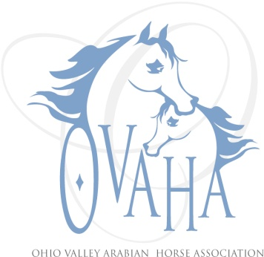

2015 Meeting Attendance/Minutes

Date of Meeting: __9-27-2015_____

P Officers P Board Members P Committee Chairs
P | Sherri Lewis - President | P | LaDon Donohoe ('15) |  | Becky Pitcock (Mbr)
 | Tammy Hawkey - Vice President |  | Caity Heigel (‘14)
P | Sharon Hanks - Secretary | P | Kristin Herder (’15) |  | Denise Mealy (Web)
P | Claire Williams - Treasurer | P | Larry Kinneer(’14) |  | Joe Subler (Hospitality)
 | Marcia Doncaster Past President (resigned) | P | Linda Laufer (’14) |  | Sherri Lewis (SS)
 |  |  | Trv-lyn Matta ('15) |  | Claire Williams (Youth)
 | Quorum
Meeting: Regular or Special
Notice given: Via e-mail, web page and Facebook page
Also present: Brian Donohoe, Caitlin Donohoe, and Rob Williams
Location and Time: 2:00, Claire Williams house (790 Billman Rd, New Madison, OH 45346)

Secretary: Minutes read. Accepted as read. Motion made by Larry, 2nd by Linda, passed, no dissent.

Larry asked about the charity (re: donation in honor of Kari). We need to re-check with Tammy for club donation ($500).

Sherri did handle sending planter/flowers ($100).

Treasurer: Claire handed out financial reports (atch'd) and went over them. Strawberry Festival made $6390.69. Our webpage expenses have basically doubled to $246 for website. Non-profit fee, filing status (determined to be every 5 years). Need to add the $100 for the flowers and $500 to charity needs to be added. Increase Misc Expenses for funerals, etc to $200. Approximately $455 left from 25% of Strawberry for philanthropy. Went over Sizzler budget - we made money. Need additional radios for communication between dressage and main ring. Motion made by Linda to accept budget as presented with noted changes, Larry 2nd, motion passed. Re: Sizzler felt we should keep dressage.

Philanthropy: Good for check ($500) to Hospice of Miami County (will verify).

New Business: $455 left for charity.

COMMIT: Remove requirement to attend 2 regular meetings. No tack sale requirement. Change deadline to 31 Jan, will review and notify by March. Must work Strawberry Festival.

Philanthropy: Motion made for educational clinic. Possibly in March. Motion made to budget $1000 for educational clinic. Motion made by Larry, 2nd by Claire, motion passed. Committee to work on it will be Brian, Larry, Linda and Sherri. Facility will be Brian, speakers will be Linda, promotion will be Larry. Possible topics discussed were dressage, saddle fit, dentistry (equine), and alternative health.

Convention: Club had 47 members on 30 June 2015, so only have one vote/delegate this year (50 is threshold for another representative). Motion made for Sherri to go as representative and allow $1000 for budget of delegate, and if alternate goes budget $500 for them. Larry made the motion, Linda 2nd - motion passed.

Claire motioned $250 for Horseman's Distress fund, and $205 for 4 Freedom, Larry 2nd - motion passed.

Christmas Party: Date December 13, at Basil's.

Note March 5th 2016 is Region 14 Award Banquet.

Meeting adjourned at appx 3:15.

