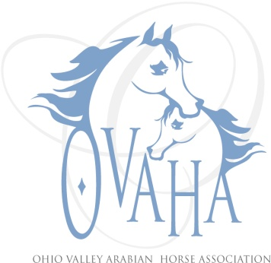

2015 Meeting Attendance/Minutes

Date of Meeting: ___2-28-2015_________

P Officers P Board Members P Committee Chairs
P | Sherri Lewis - President |  | LaDon Donohoe ('15) | P | Becky Pitcock (Mbr)
 | Tammy Hawkey - Vice President |  | Caity Heigel (‘14)
P | Sharon Hanks - Secretary | P | Kristin Herder (’15) |  | Denise Mealy (Web)
 | Claire Williams - Treasurer | P | Larry Kinneer(’14) |  | Joe Subler (Hospitality)
 | Marcia Doncaster Past President (resigned) | P | Linda Laufer (’14) |  | Sherri Lewis (SS)
 |  |  | Trv-lyn Matta ('15) |  | Claire Williams (Youth)
 | Quorum
Meeting: Regular or Special Sizzler

Notice given: Via e-mail, web page and Facebook page

Also present: Andrea Wolfe, Gordon Lewis, Dale Pitcock, Susan

Location and Time: Panera Bread, Miller's Lane, Dayton, OH start 3:45p.m.

Debbie Reid and Jack Burkhimer, officials from PA, will share car ride.

Sandy Chohany, offical from IL for Sport Horse and Dressage.

We will do a dressage clinic Friday night. Cost will be $10 a head. The Steward is Kandy Lazarrus.

Andrea will do a chart for volunteers and tasks.

Chris Hilsaymer will be the farrier.

Sport Horse classes on Saturday and Dressage on Sunday.

Will also add USEF English Pleasure Driving, Hunt, and Saddleseat classes.

Meeting adjourned at 5:00p.m.

