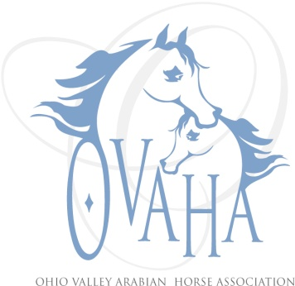

2015 Meeting Attendance/Minutes

Date of Meeting: __1-17-2015__________

P Officers P Board Members P Committee Chairs
P | Sherri Lewis - President |  | LaDon Donohoe ('15) |  | Becky Pitcock (Mbr)
 | Tammy Hawkey - Vice President |  | Caity Heigel (‘14) | P | Laraine Hune (TAIL)
P | Sharon Hanks - Secretary | P | Kristin Herder (’15) |  | Denise Mealy (Web)
P | Claire Williams - Treasurer | P | Larry Kinneer(’14) |  | Joe Subler (Hospitality)
 | Marcia Doncaster Past President (resigned) | P | Linda Laufer (’14) |  | Sherri Lewis (SS)
 |  | P | Trv-lyn Matta ('15) |  | Claire Williams (Youth)
 | Quorum
Meeting: Regular or Special
Notice given: Via e-mail, web page and Facebook page
Also present: Jim Bumgarner., Michael Sonntag, Gordon Lewis, Ned Hune, Matt Herder, Chuck Hanks, and Claire Williams' husband.

Location and Time: Francos Restaurant, Dayton, OH time started appx 5:25

Elections: Positions and holders will remain the same, as no new nominees or volunteers came forward. Motion was made to accept current office holders by Kristin, motion 2nd by Sharon - motion passed.

Treasurer: Claire handed out financial reports and went over them. She went over the books and balanced for 2014. Larry motioned to accept reports, Kristin 2nd - motion passed as written.

Secretary: Minutes were read from previous meeting. Larry motioned to accept as read, Kristin 2nd - motion passed.

Sizzler: The show has been turned over to Sherri Lewis for 2015.

Preble County Tack Sales. Linda Laufer will run the tables at the sale, which will be 1 March 2015. We will pay for two tables. Claire motioned to pay, Trv-lyn 2nd - motion passed.

Laraine Hune resigned from TAIL program at end of meeting. All items turned over to Sherri.

Meeting adjourned at 5:50 p.m.

